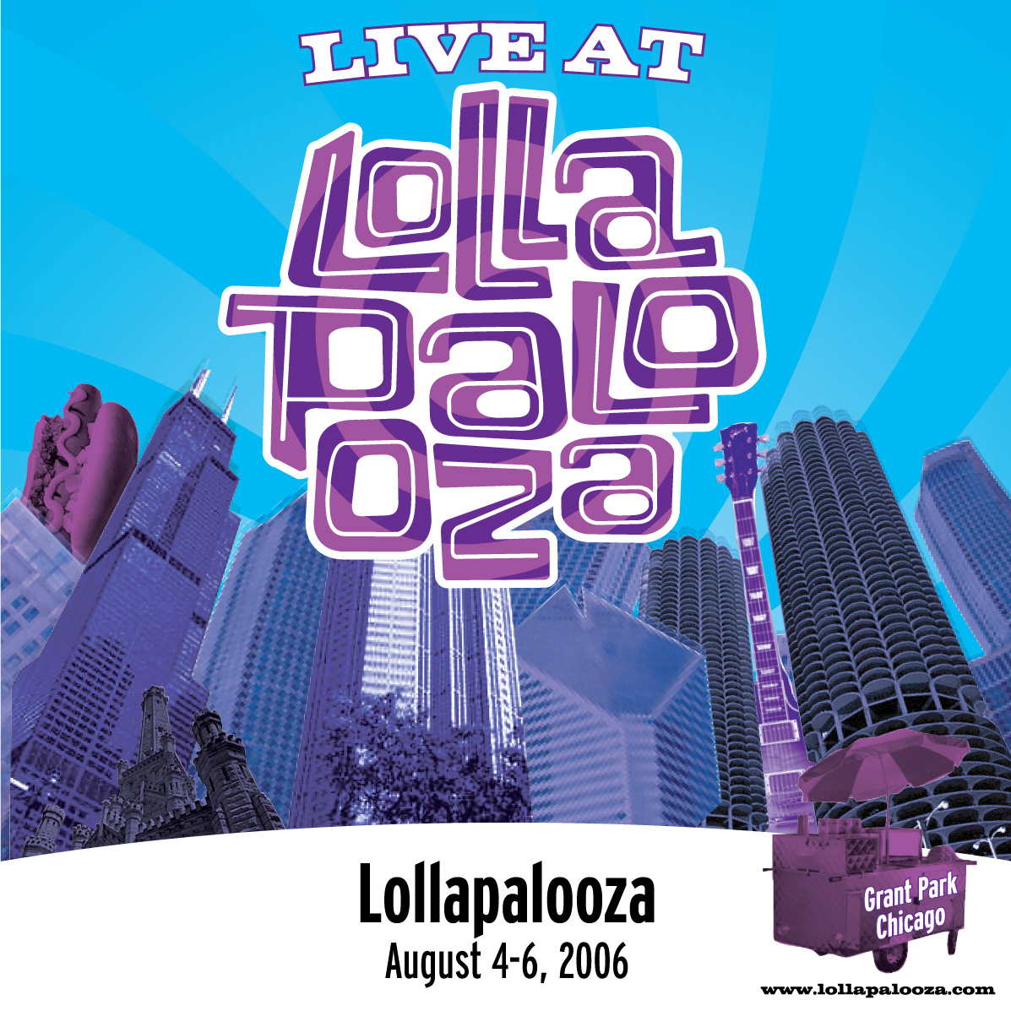
For Immediate Release
October 26, 2006
Contact: Shelby Meade, Fresh and Clean Media
310-313-7200, shelby@freshcleanmedia.com

Lollapalooza offers Live Tracks at LiveLollapalooza.com
Recordings available in MP3 and FLAC formats from 22 Performances at the 2006 Festival

Live recordings from the 2006 Lollapalooza, in Chicago, are now available on a new Web site, LiveLollapalooza.com. Music fans can download essential live tracks that were hand-picked by their favorite artists from performances at the 2006 Festival. The site has tracks from 22 bands available in MP3 and FLAC formats, as well as links to performances from 4 other bands whose recordings are available on iTunes. LiveLollapalooza.com also includes one-of-a-kind show photos taken during each band’s performance. Live recordings available through LiveLollapalooza.com include performances by:

- Broken Social Scene  - Sleater-Kinney  - Umphrey's McGee  - Blues Traveler  - The Hold Steady  - Ben Kweller  - Iron & Wine  - Blue October *  - Wolfmother * | - Stars  - The Disco Biscuits  - Poi Dog Pondering  - The Go! Team  - Cursive  - Smoking Popes  - Editors  - Lyrics Born  - Office | - Andrew Bird  - The Frames  - Matt Costa *  - deadboy & the Elephantmen  - Benevento-Russo Duo  - Be Your Own Pet *  - Mucca Pazza  - Particle
The “Live at Lollapalooza” series demonstrates the diversity and depth of the 2006 lineup—which helped secure a 2006 Billboard “Top Festival” nomination. The series includes many highlight performances from the three-day festival in Chicago, including a rare Broken Social Scene show with the band’s full lineup, Sleater-Kinney’s final festival gig before their break-up, a buzz-worthy set from indie darlings The Hold Steady, Poi Dog Pondering’s hometown Chicago showcase, and much more.

LiveLollaplaooza.com is powered by Nugs.net, a company which has created similar download sites for Bonnaroo Music & Arts Festival and artists like Dave Matthews Band, Phish, The Grateful Dead, Metallica, and many more.

* Available on iTunes

For more info, visit www.lollapalooza.com or contact Shelby Meade at Fresh and Clean Media (310-313-7200, shelby@freshcleanmedia.com).

About Lollapalooza (www.lollapalooza.com)

Lollapalooza originated as the brainchild of perpetual tastemaker and visionary Perry Farrell. The traveling festival took to the road in 1991 and broke new ground in the live music landscape. Alumni such as Beck, Pearl Jam, and Green Day found a place to be heard by a hungry audience of alternative music fans. In 2005, producers Capital Sports & Entertainment and Charles Attal Presents reimagined Lollapalooza as a destination, experience-based festival along the lines of the Austin City Limits Music Festival, which the two companies created and produce.

Lollapalooza is presented by Parkways Foundation and produced by Capital Sports & Entertainment and Charles Attal Presents. They are partnered with Farrell, co-producer of Lollapalooza, and the William Morris Agency.

About NugsNet (www.nugs.net)

Music service provider nugs.net enterprises offers a turn-key solution for online music distribution. The nugs.network currently delivers music downloads for over 250 artists including Dave Matthews Band, Metallica, Phish, the Grateful Dead, and Widespread Panic. Private label websites within the nugs.network include LivePhish.com, LiveMetallica.com, LiveWidespreadPanic.com, LiveDownloads.com, LiveCheese.com, and the free music channel at stash.nugs.net.

The nugs.network delivers over 3 million downloads per month to nearly 1 million users. More than 50,000 users each month listen to nugs.net Internet radio and download monthly podcasts from nugs.net live music archives.



Printed on recycled paper

